State of Hawaiʻi, Division of Forestry and Wildlife
Kauaʻi Branch
INVITATION FOR BIDS
OFFERS
FOR

Solicitation #:
KAʻULA ISLET SURVEY RESEARCH VESSEL
STATE OF HAWAII
DEPARTMENT OF LAND & NATURAL RESOURCES

WILL BE RECEIVED UP TO 2:00 PM (HST) ON
Tuesday, September 1st 2026
ELECTRONICALLY THROUGH THE STATE OF HAWAII ELECTRONIC
PROCUREMENT SYSTEM (HIePRO)

STATE OF HAWAII
DEPARTMENT OF LAND AND NATURAL RESOURCES
DIVISION OF FORESTRY AND WILDLIFE
1151 PUNCHBOWL STREET, ROOM 325
HONOLULU, HAWAII 96813
NOTICE TO OFFERORS
Specifications for Solicitation No. “KA’ULA ISLET SURVEY RESEARCH VESSEL” are available for download on the State of Hawaii Electronic Procurement System (HIePRO). All offers are due through electronic submittal on HIePRO by:
9/1/2026
Time: 2:00 PM (HST)

At the time of the Award, Offeror shall be compliant with the State Rules and Regulations through Hawaii Compliance Express (HCE), if not compliant, award shall not be issued. Offeror shall submit the original signed OFFER FORMS for KA’ULA ISLET SURVEY RESEARCH VESSEL uploaded to HIePRO.
The award, if awarded, shall be subject to the availability of funds.

Contact: Benjamin Wells, DOFAW Kauai, (808) 631-5013

Scope of Work
The Division of Forestry and Wildlife (DOFAW), Kauaʻi Branch has received a Federal grant to execute research at one of Hawaii’s offshore islands, Kaʻula Islet (or Kaʻula Rock). Due to the sensitive nature of the site all research will be conducted remotely by Unmanned Aerial Vehicle (UAV) or drone from a suitable research vessel, over a period of several (estimated 3 to 4) working research days. The work involves the delivery and recovery of scientific monitoring equipment, utilizing UAVs, from the deck of the research vessel. This work also entails a comprehensive floristic and faunal survey of the islet, requiring the participation of 6-7 research staff for the duration of the trip. Close cooperation between field team and research vessel captain and crew will be essential to successful operations.

Dates (prospective)
At minimum two (2) trips consisting of 3-4 on-site working days plus transit time. Prospective times include December 2026, March-May 2027, and June-September 2027. These dates are not final and may be changed in consultation with vendor.

Services Requested
1. Round-trip transportation of cargo and field staff from Kauaʻi, delivery to site, continued operations at site for 3-4 days, and return (prospective route below).
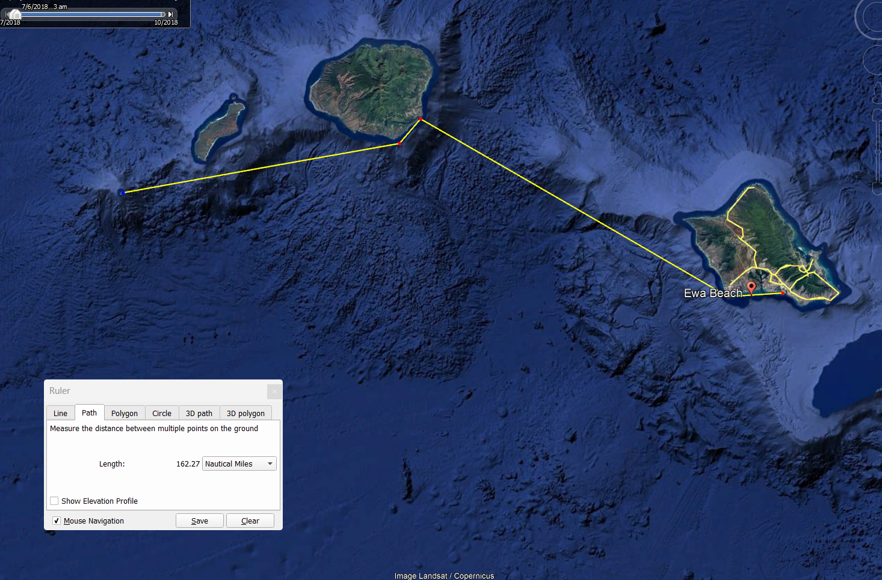
Vendor Requirements
Due to the approach and number of personnel involved in the research study, vessel stability and space aboard are of high importance. The demands of the research study are reflected in the requirements below. Previous experience conducting scientific research operations is strongly encouraged.

Requirements:
- The vessel must be able to operate minimum 12-hour working days on-site for 4 consecutive days, with reliable transit to and from site and night moorings.

- Vessel must be able to load and unload research team and equipment from a Kauaʻi port.

- Stabilizing elements (fins, bridge wing control station, etc.) to allow for less roll and fine maneuvering during precise UAV operations.
- Bunk, bathroom and dining space for 6-7 individual passengers.

- Sufficient deck space for the simultaneous operating of two UAV platforms, including landing and storage and attachment of monitoring equipment, with deck dimensions of at least 10x15ft.

- Sufficient power generation with outlets and charging capacity to 120/240v (preferably near to UAV launch deck space) and a loading crane arm to deliver UAV units and equipment to tender if needed.

- An area of high visibility (preferably elevated) for UAV spotting operations and visual monitoring of seabirds.
- Vessel must have up to date hull inspections; ballast water inspection; rat inspection; Vessel Monitoring System (VMS) installed as well as long-range onboard communications equipment able to contact facilities on Oahu and Kauaʻi from site.

- Due to Federal requirements for safety and compliance, vendors must have up-to-date U.S. Coast Guard safety inspections and be equipped with safety equipment including firefighting equipment, ventilation and backfire flame control.
- Vessel must be able to acquire all necessary permits for marine operations in the research area and for transportation of equipment including lithium batteries.

Ideal bidder:
Depending on vessel size and draft, as well as conditions, additional work may need to be performed from nearer to shore, and the ideal vessel also has a large (15-20’), stable tender (Zodiac or equivalent), with crew qualified to operate it in nearshore areas.
Having crew who meet OSHA 30hr General Industry standards aboard is preferred for operational compliance.
Internet access via Starlink or similar is preferred.

Availability
Vessel should be made available for research periods for exclusive use by DOFAW during 1-week windows to be set in consultation with research team.
Biosecurity
Due to the ecologically sensitive nature of the study site, biosecurity procedures (rat line-guards on moorings, rat and insect trap deployment, etc.) will be implemented before departure to DOFAW standards. Vessel and crew will conduct required pre-trip cleaning, trapping and reporting for biosecurity measures.

